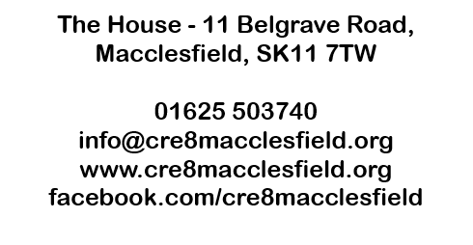

Banker’s Order
To: |  | The Manager |  |  | Bank Name:
Address of bank (including postcode)
Your account details
Sort code: |  |  |  |  | Account number:
Account name:
Please pay Cre8 the sum of: |  |  |  | £
(In words)
The first payment is to be made on:
Further payments should be made: (please delete as appropriate) |  |  |  | Monthly / Quarterly / Annually
Please pay to:
Unity Trust Bank plc, Nine Brindleyplace, Birmingham, B1 2HB
Sort code: |  |  | 60 83 01 |  | Account number: |  | 20269850
Account name: |  |  | Cre8 Macclesfield Ltd
This banker’s order replaces any existing banker’s order in favour of Cre8 Macclesfield Ltd

Signed: |  |  |  |  |  |  | Date:
Full name:
Address & Postcode
Once this form has been completed please return to Sarah Postlewhite at Cre8 at the address at the top of the form. It will then be forwarded on to your bank so they can set up the standing order.

