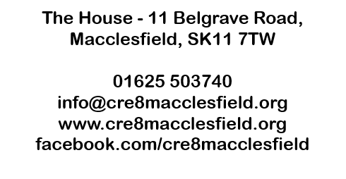

Banker’s Order
To: |  | The Manager |  |  | Bank Name:
Address of bank (including postcode)
Your account details
Sort code: |  |  |  |  | Account number:
Account name:
Please pay Cre8 the sum of: |  |  |  | £
(In words)
The first payment is to be made on:
Further payments should be made: (please delete as appropriate) |  |  |  | Monthly / Quarterly / Annually
Please pay to:
Unity Trust Bank plc, Nine Brindleyplace, Birmingham, B1 2HB
Sort code: |  |  | 60 83 01 |  | Account number: |  | 20269850
Account name: |  |  | Cre8 Macclesfield Ltd
This banker’s order replaces any existing banker’s order in favour of Cre8 Macclesfield Ltd

Signed: |  |  |  |  |  |  | Date:
Full name:
Address & Postcode

Once this form has been completed please return to Katy Wardle at Cre8 at the address at the top of the form. It will then be forwarded on to your bank so they can set up the standing order.
Gift Aid Declaration
Charity Name | Cre8 Macclesfield Ltd
Charity No. | 1147150
Details of Donor:
Name
Address and postcode
Declaration by Donor:
I would like the charity to treat all subscriptions or donations I have made since 30th April 2012, and all subscriptions or donations I make from the date of this declaration, until I notify you otherwise, as Gift Aid donations.
Signed
Date
Important Notes:
1. You can cancel this Declaration at any time by notifying the charity.
2. If in the future your circumstances change and you no longer pay tax on your income and capital gains equal to the tax that the charity reclaims, you can cancel your declaration.
3. If you pay tax at the higher rate you can claim further tax relief in your Self Assessment tax return.
4. If you are unsure whether your donations qualify for Gift Aid tax relief, ask the charity, or refer to the HMRC information relating to donations by individuals.
5. Please notify the charity if you change your name or address.

If you have any questions, require a copy of this form, or need to change or cancel your declaration, please call Cre8 on 01625 503740.

