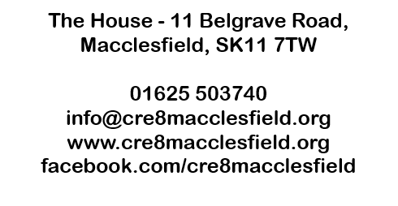
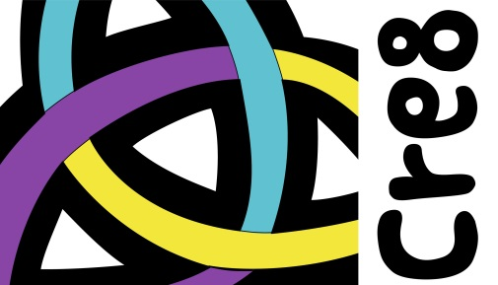

Gift Aid Declaration
Charity Name | Cre8 Macclesfield Ltd
Charity No. | 1147150
Details of Donor:
Name
Address and postcode
Declaration by Donor:
I would like the charity to treat all subscriptions or donations I have made since 30th April 2012, and all subscriptions or donations I make from the date of this declaration, until I notify you otherwise, as Gift Aid donations.
Signed
Date
Important Notes:
1. You can cancel this Declaration at any time by notifying the charity.
2. If in the future your circumstances change and you no longer pay tax on your income and capital gains equal to the tax that the charity reclaims, you can cancel your declaration.
3. If you pay tax at the higher rate you can claim further tax relief in your Self Assessment tax return.
4. If you are unsure whether your donations qualify for Gift Aid tax relief, ask the charity, or refer to the HMRC information relating to donations by individuals.
5. Please notify the charity if you change your name or address.

If you have any questions, require a copy of this form, or need to change or cancel your declaration, please call Cre8 on 01625 503740.

